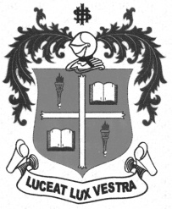
LOYOLA COLLEGE (AUTONOMOUS), CHENNAI – 600 034
M.A. DEGREE EXAMINATION - APPLIED HISTORY
FOURTH SEMESTER – APRIL 2012

HT 4812 - ARCHIVAL MANAGEMENT

Date : 16-04-2012 Dept. No. Max. : 100 Marks

Time : 1:00 - 4:00
PARI-A
Answer any four of the following in a page each (4x5=20)

- Archives
- Record
- Madras Record Office
- Acquisition of Records
- Vacuum Fumigation
- Microfilm

PART-B

Answer any two of the following in two pages each (2x10=20)

- Explain the various definitions of archives.
- Enumerate the cultural importance of archives.
- Elucidate the skills that an archivist has to possess.
- Explicate the different preservation techniques of a document.

PART-C
Answer any three of the following in four pages each (3x20=60)

- Describe the functions and uses of archives.
- Narrate the evolution of Tamilnadu Archives.
- Portray the historical development of National Archives.
- Analyse the process of Record Management.
- Depict the different duties that an archivist fulfills.

******

